Laborator.2.IS

Atayeva Bahar.

**EX.1**

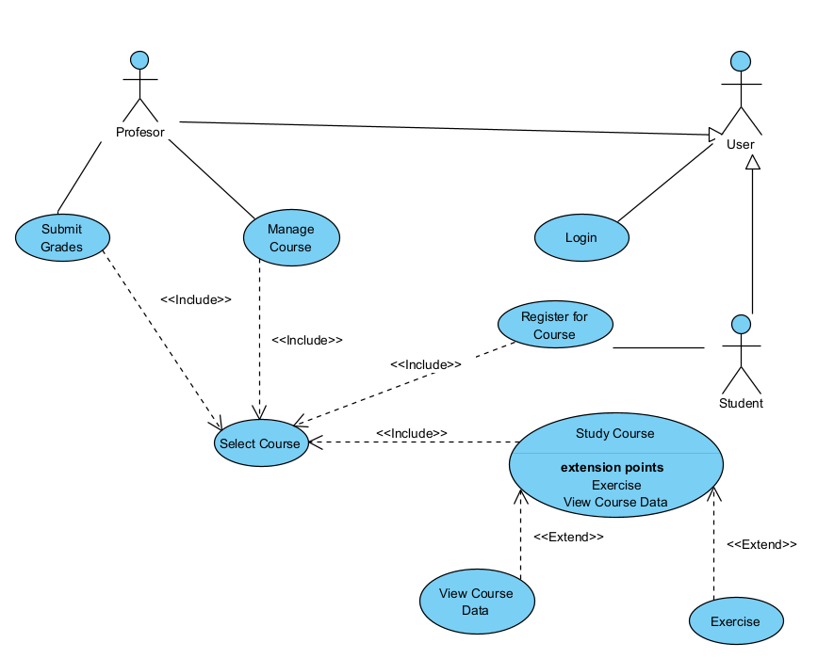

**EX 2.**

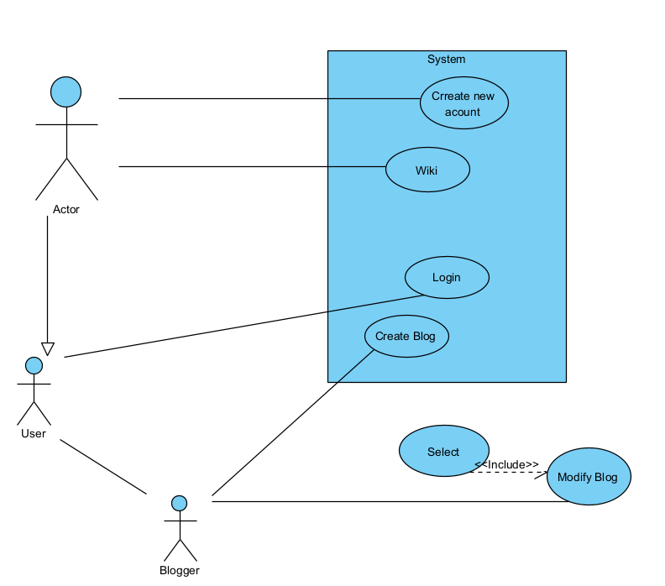

**EX 3.**

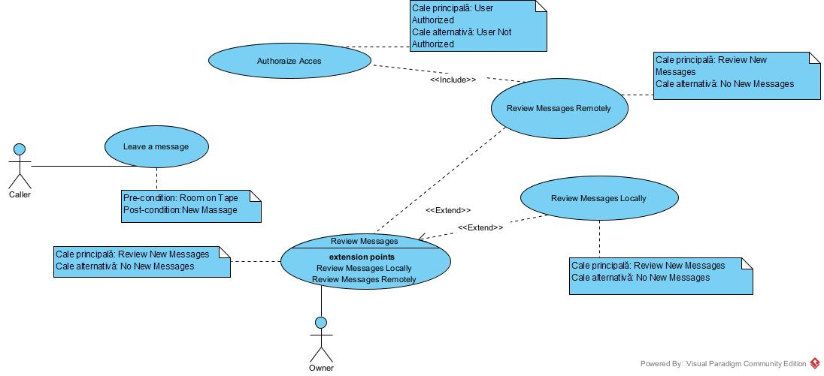

**EX 4.  
  
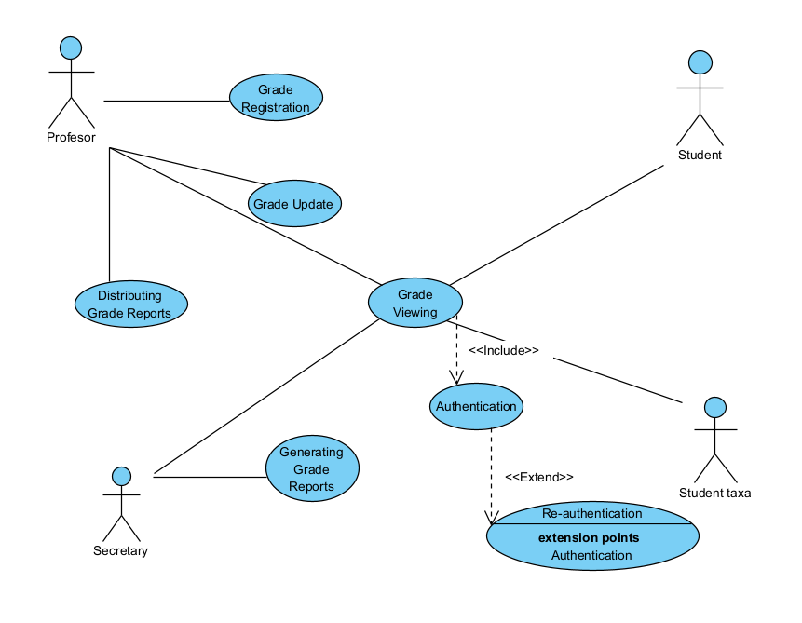**

1)

The actors involved in the system are:

- Professor

- Student

- Fee-paying Student (specialization of Student)

- Secretary

2)

- General actor: Student

- Specialized actor: Fee-paying Student

- The relationship between them is a generalization/specialization (inheritance) relationship.

3)

The system's use cases are:

- Grade Registration (Professor)

- Grade Update (Professor)

- Grade Viewing (Professor, Student, Secretary)

- Authentication (Professor, Student, Secretary)

- Generating Grade Reports (Secretary)

- Distributing Grade Reports (Professor)

4)

- The Authentication use case is always used before Grade Viewing.

- The relationship between them is of type «include» (the Authentication use case is always included in Grade Viewing).

5)

- The Re-authentication use case is sometimes used by Authentication in case of a login failure.

- The relationship between them is of type «extend» (Re-authentication extends Authentication only in case of failure).

6)

plaintext

actor Professor

actor Student

actor "Fee-paying Student" as StudentTaxa

actor Secretary

StudentTaxa --|> Student // Specialization

usecase "Grade Registration" as UC1

usecase "Grade Update" as UC2

usecase "Grade Viewing" as UC3

usecase "Authentication" as UC4

usecase "Re-authentication" as UC5

usecase "Generating Grade Reports" as UC6

usecase "Distributing Grade Reports" as UC7

Professor --> UC1

Professor --> UC2

Professor --> UC3

Professor --> UC7

Student --> UC3

StudentTaxa --> UC3

Secretary --> UC3

Secretary --> UC6

UC3 --> UC4 : <<include>>

UC4 --> UC5 : <<extend>>